Image | 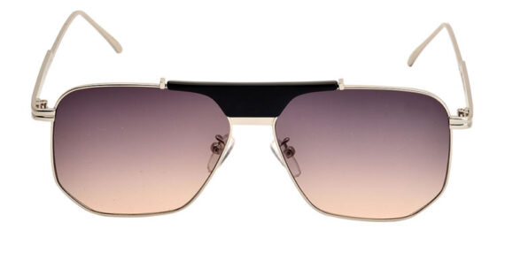
Brand | RAYBAN
Model Name | Grainne
Price | RS 1800
PRODUCT DETAILS

